**How to install Zygo App by Ammar Al-Jodah**

1. Move zygo_app folder to c:\zygo_app
2. Open Matlab
3. put the path of matlab to as the path of this folder c:\zygo_app run this command: uiopen('Zygo_App.mlappinstall',1) Click Install
4. for this app to work, you need to have the instrumentation toolbox with visa support. This app is tested under MATLAB 2017b . You need to add visa support into matlab to do that google "visa support matlab" and install the file and follow the installation steps. you can use this link <https://au.mathworks.com/hardware-support/ni-visa-keysight-visa-tekvisa.html> and click on For National Instruments : Get support Package or you can use this file "nivisaandicp.mlpkginstall" instead of downloading it however this file is tested for MATLAB2017b
5. you need to install NI-VXI 16.0 for Windows nivxi1600.exe, it is free software and can be downloaded from <http://www.ni.com/download/ni-vxi-16.0/6562/en/> or use this file "nivxi1600.exe"
6. Before run Zygo_App the VME-PCI card needs to be configure in NI MAX as shown in NI_MAX1.png and NI_MAX2.png
7. For more cards you need to set the VME address on cards (by setting the switches on card itself)as follow
8. Card 3 vme address 0x003000 to 0x303f, card 4 : 0x004000 to 0x403f, card 5: 0x005000 to 0x503f, etc
9. For logical address use 410,415,420,etc

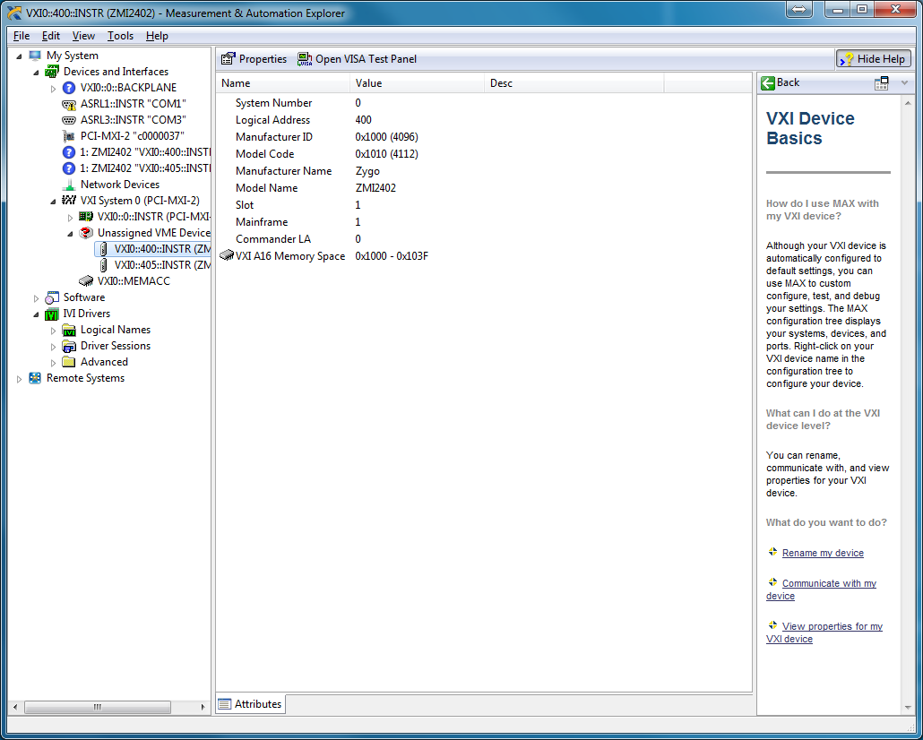

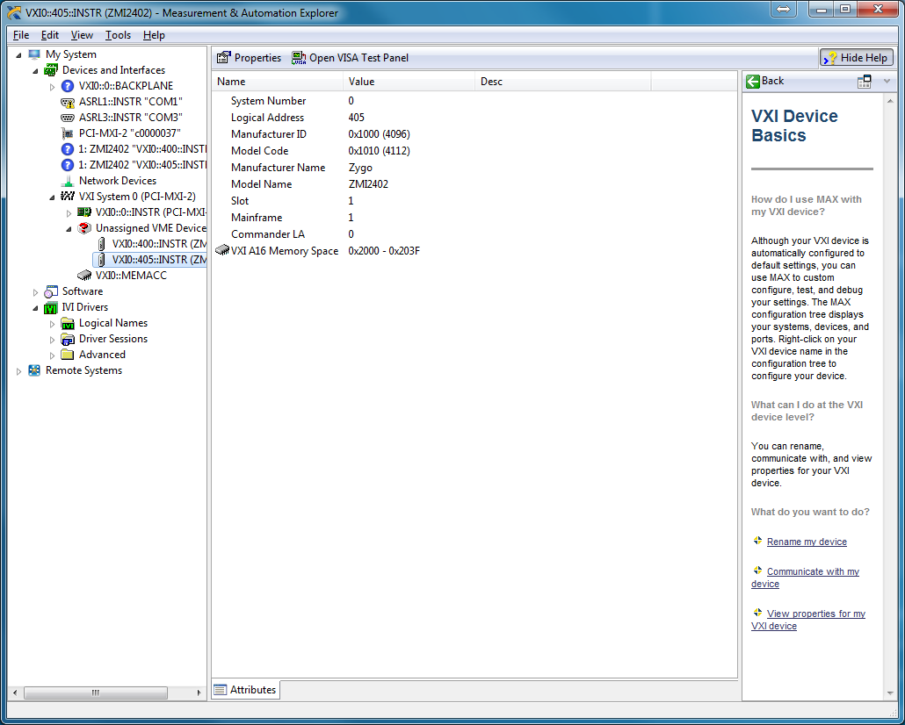

**How to install blocks**

1. Copy the content of the folder "thirdpartydrivers" to

C:\Program Files\MATLAB\R2017b\toolbox\rtw\targets\xpc\target\build\xpcblocks\thirdpartydrivers

use copy and replace if any file already existed.

1. you need to install a supported compiler for matlab "Microsoft Visual C++ 2015 (C)" has been used during the devlopment of these toolbox, after installation use mex '-setup' to select this compiler
2. Open MATLAB and put the following code in m-file and run it:

mex 'zygo.c'

mex 'dw2bits.c'

mex 'do8316.c'

mex 'din8316.c'

mex 'daaob8.c'

mex 'daa8316.c'

rehash toolbox

Close MATLAB and open it agian, the new toolbox should appear as "Simulink Real-Time: RMRL_Lib Blockset"

1. to connect to target use the command slrtexplr
2. use the settings shown in "adapter setting.png" and "target setting.png"

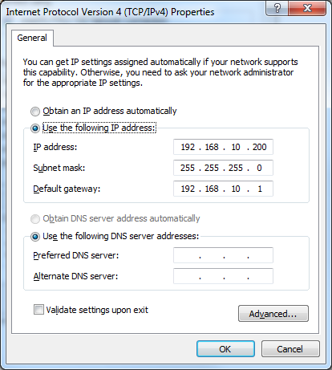

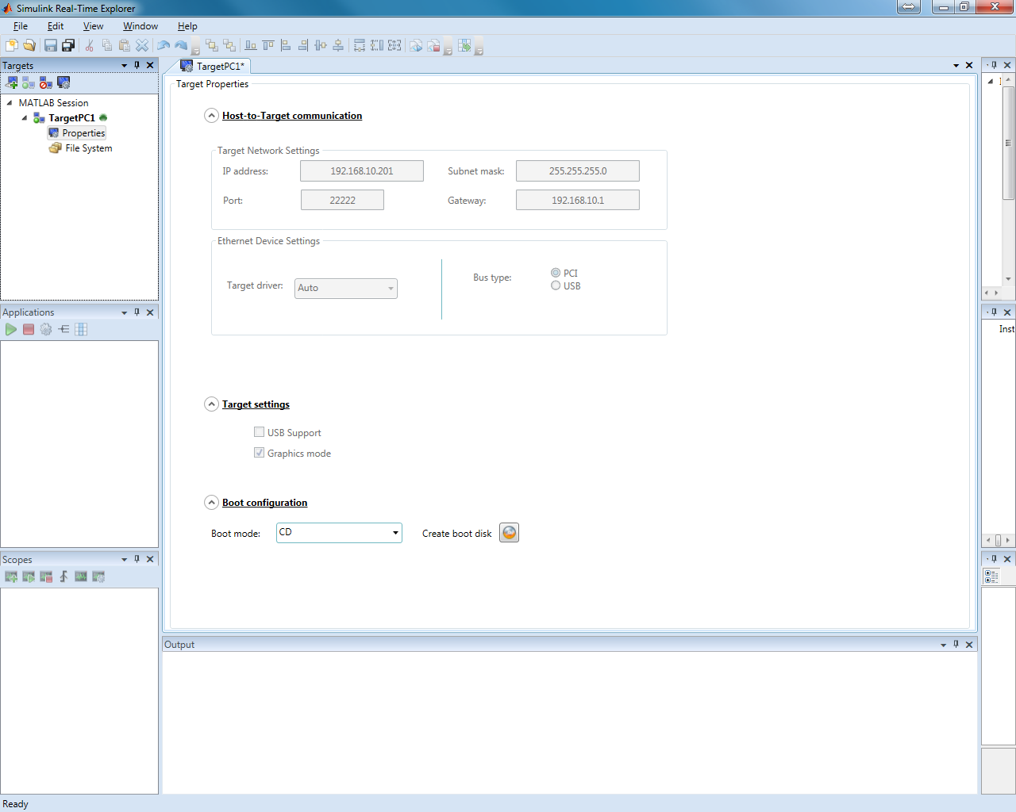

Burn a CD by clicking on “Create boot disk”, boot the target PC from this CD.

1. if you have intel external network card then use the installation procedure in

"setup of the external network card1.png"

"setup of the external network card2.png"

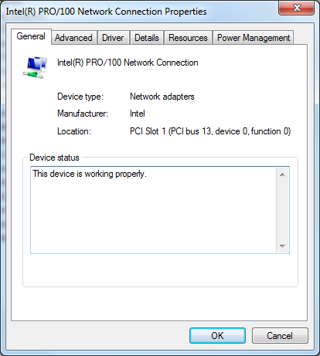

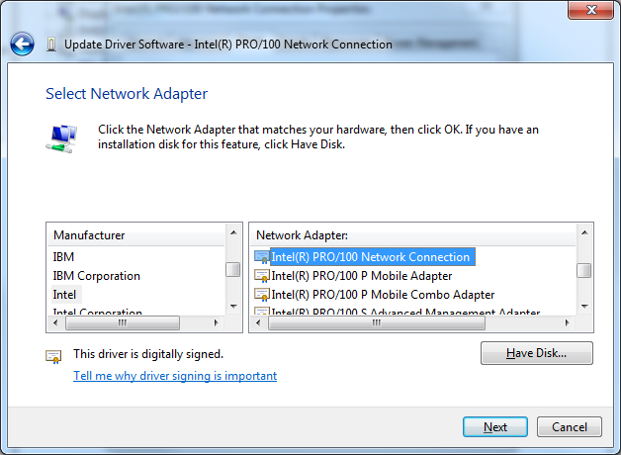

**Test Simulink files**

1. Move the folder "realtime_simulink_files" to "c:\realtime_simulink_files"
2. Use "c:\realtime_simulink_files\template\template_sim_realtime.slx" as starting point to develop your model